CoderDojoDC Raspberry Pi Workstation Setup

Everything you will need is stored on our metal storage cart. We have labeled all items needed for your workstation setup. There are 11 stations, so the plastic containers, monitors, and keyboards are labeled from 1 to 11. Make sure you take a matching set.

**From the storage cart, take one each of these - and make sure they have the same number **pay extra attention if you have 6 or 9, thesde pieces get easily mixed up :)**

1. Keyboard
2. Monitor
3. Clear box with Raspberry Pi and accessories

In this clear box with purple handle, you will find the following items

1. Raspberry Pi 3 with battery attached
2. green GrovePi box
3. microSD card (probably already inserted into Raspberry Pi)
4. Mouse
5. USB to miniUSB cable (for battery)
6. *power supply (optional - we are now using the battery pack attached to the RaspberryPi)*
7. *Headphones if you’d like them*
8. *MicroSD card reader w/ USB cable*

**Also from the storage cart, in another clear box with purple handles, you will need one each of**

1. HDMI cable for monitor

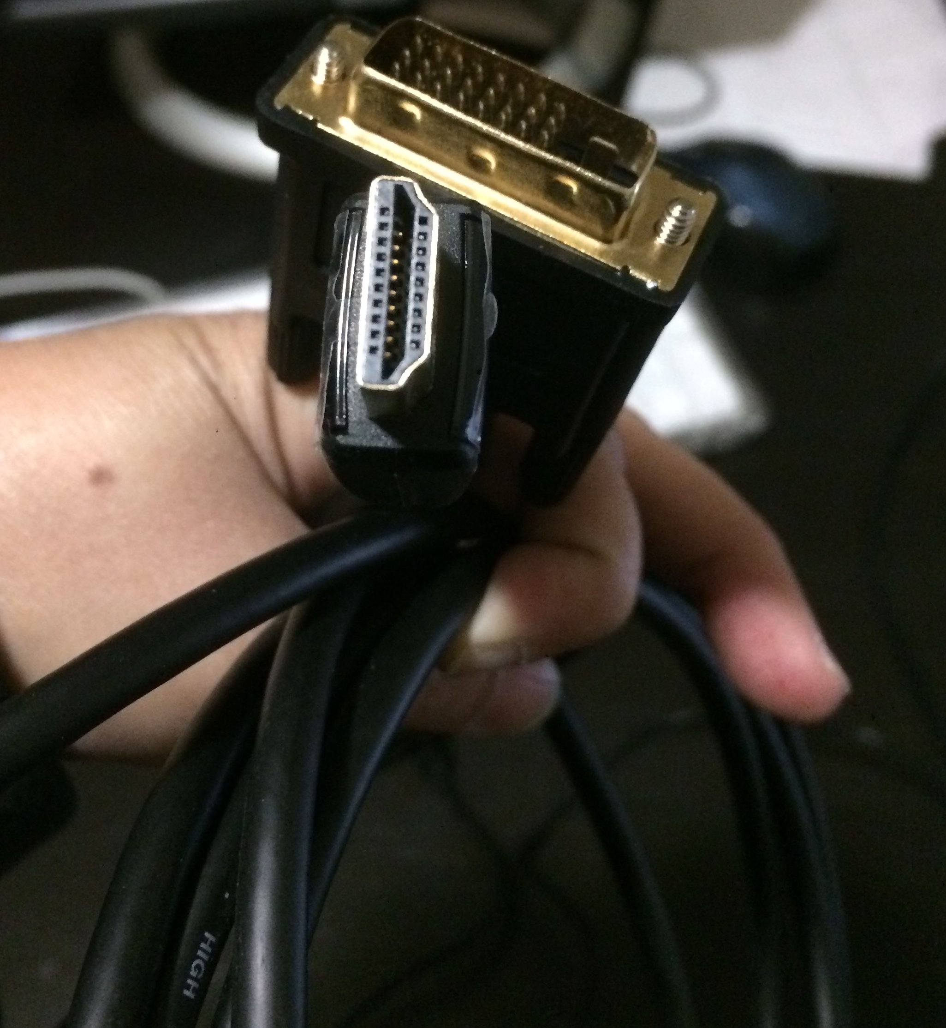

1. power cable for monitor

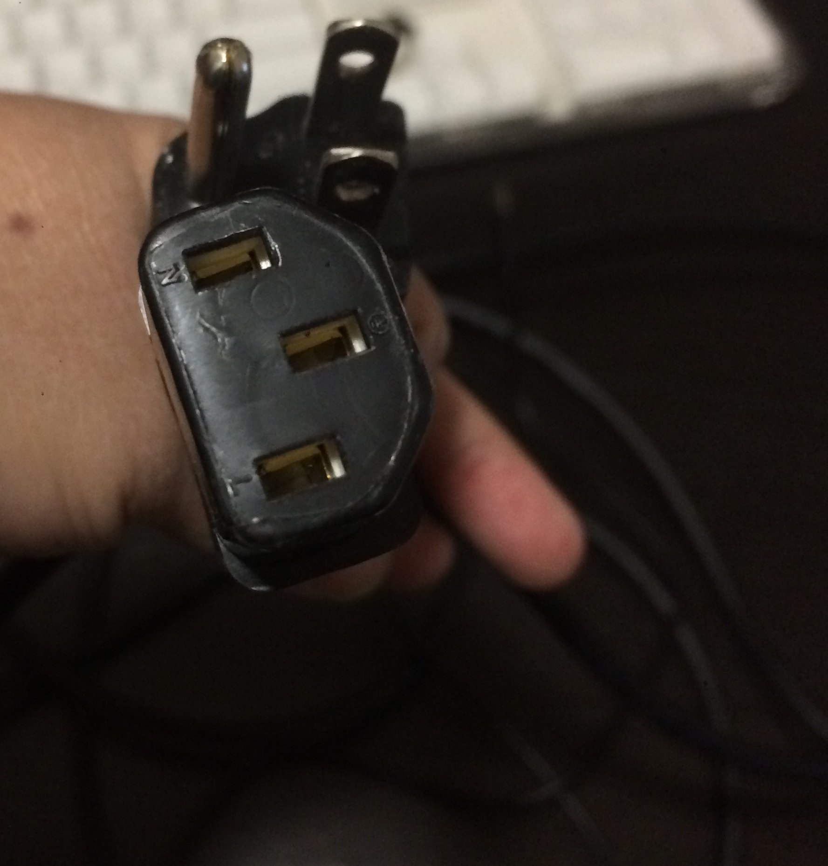

## Connecting cables to the Raspberry Pi

1. One end of the Raspberry Pi has four USB ports. Plug the keyboard into one of them.

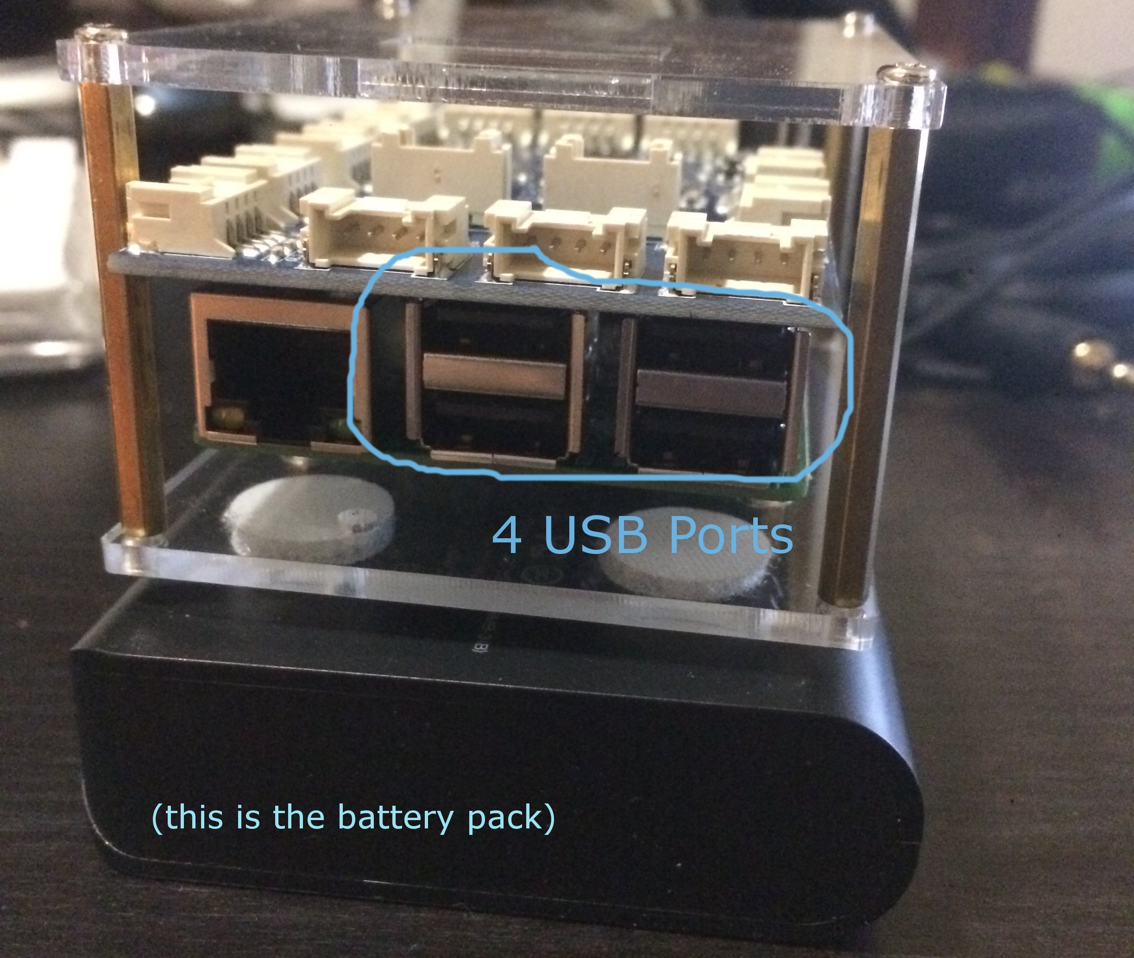

1. Next plug the mouse into a second USB port.
2. Take the power cable for the monitor, and plug the 3-prong end into a power strip.
3. Take the other end and attach to the monitor.
4. Take the HDMI cable for the monitor. One end has a much bigger part, which you need to attach to the monitor, and secure it by turning the two small pins.
5. Next find the HDMI port on the Raspberry Pi, and plug in the other, smaller part of the HDMI cable.

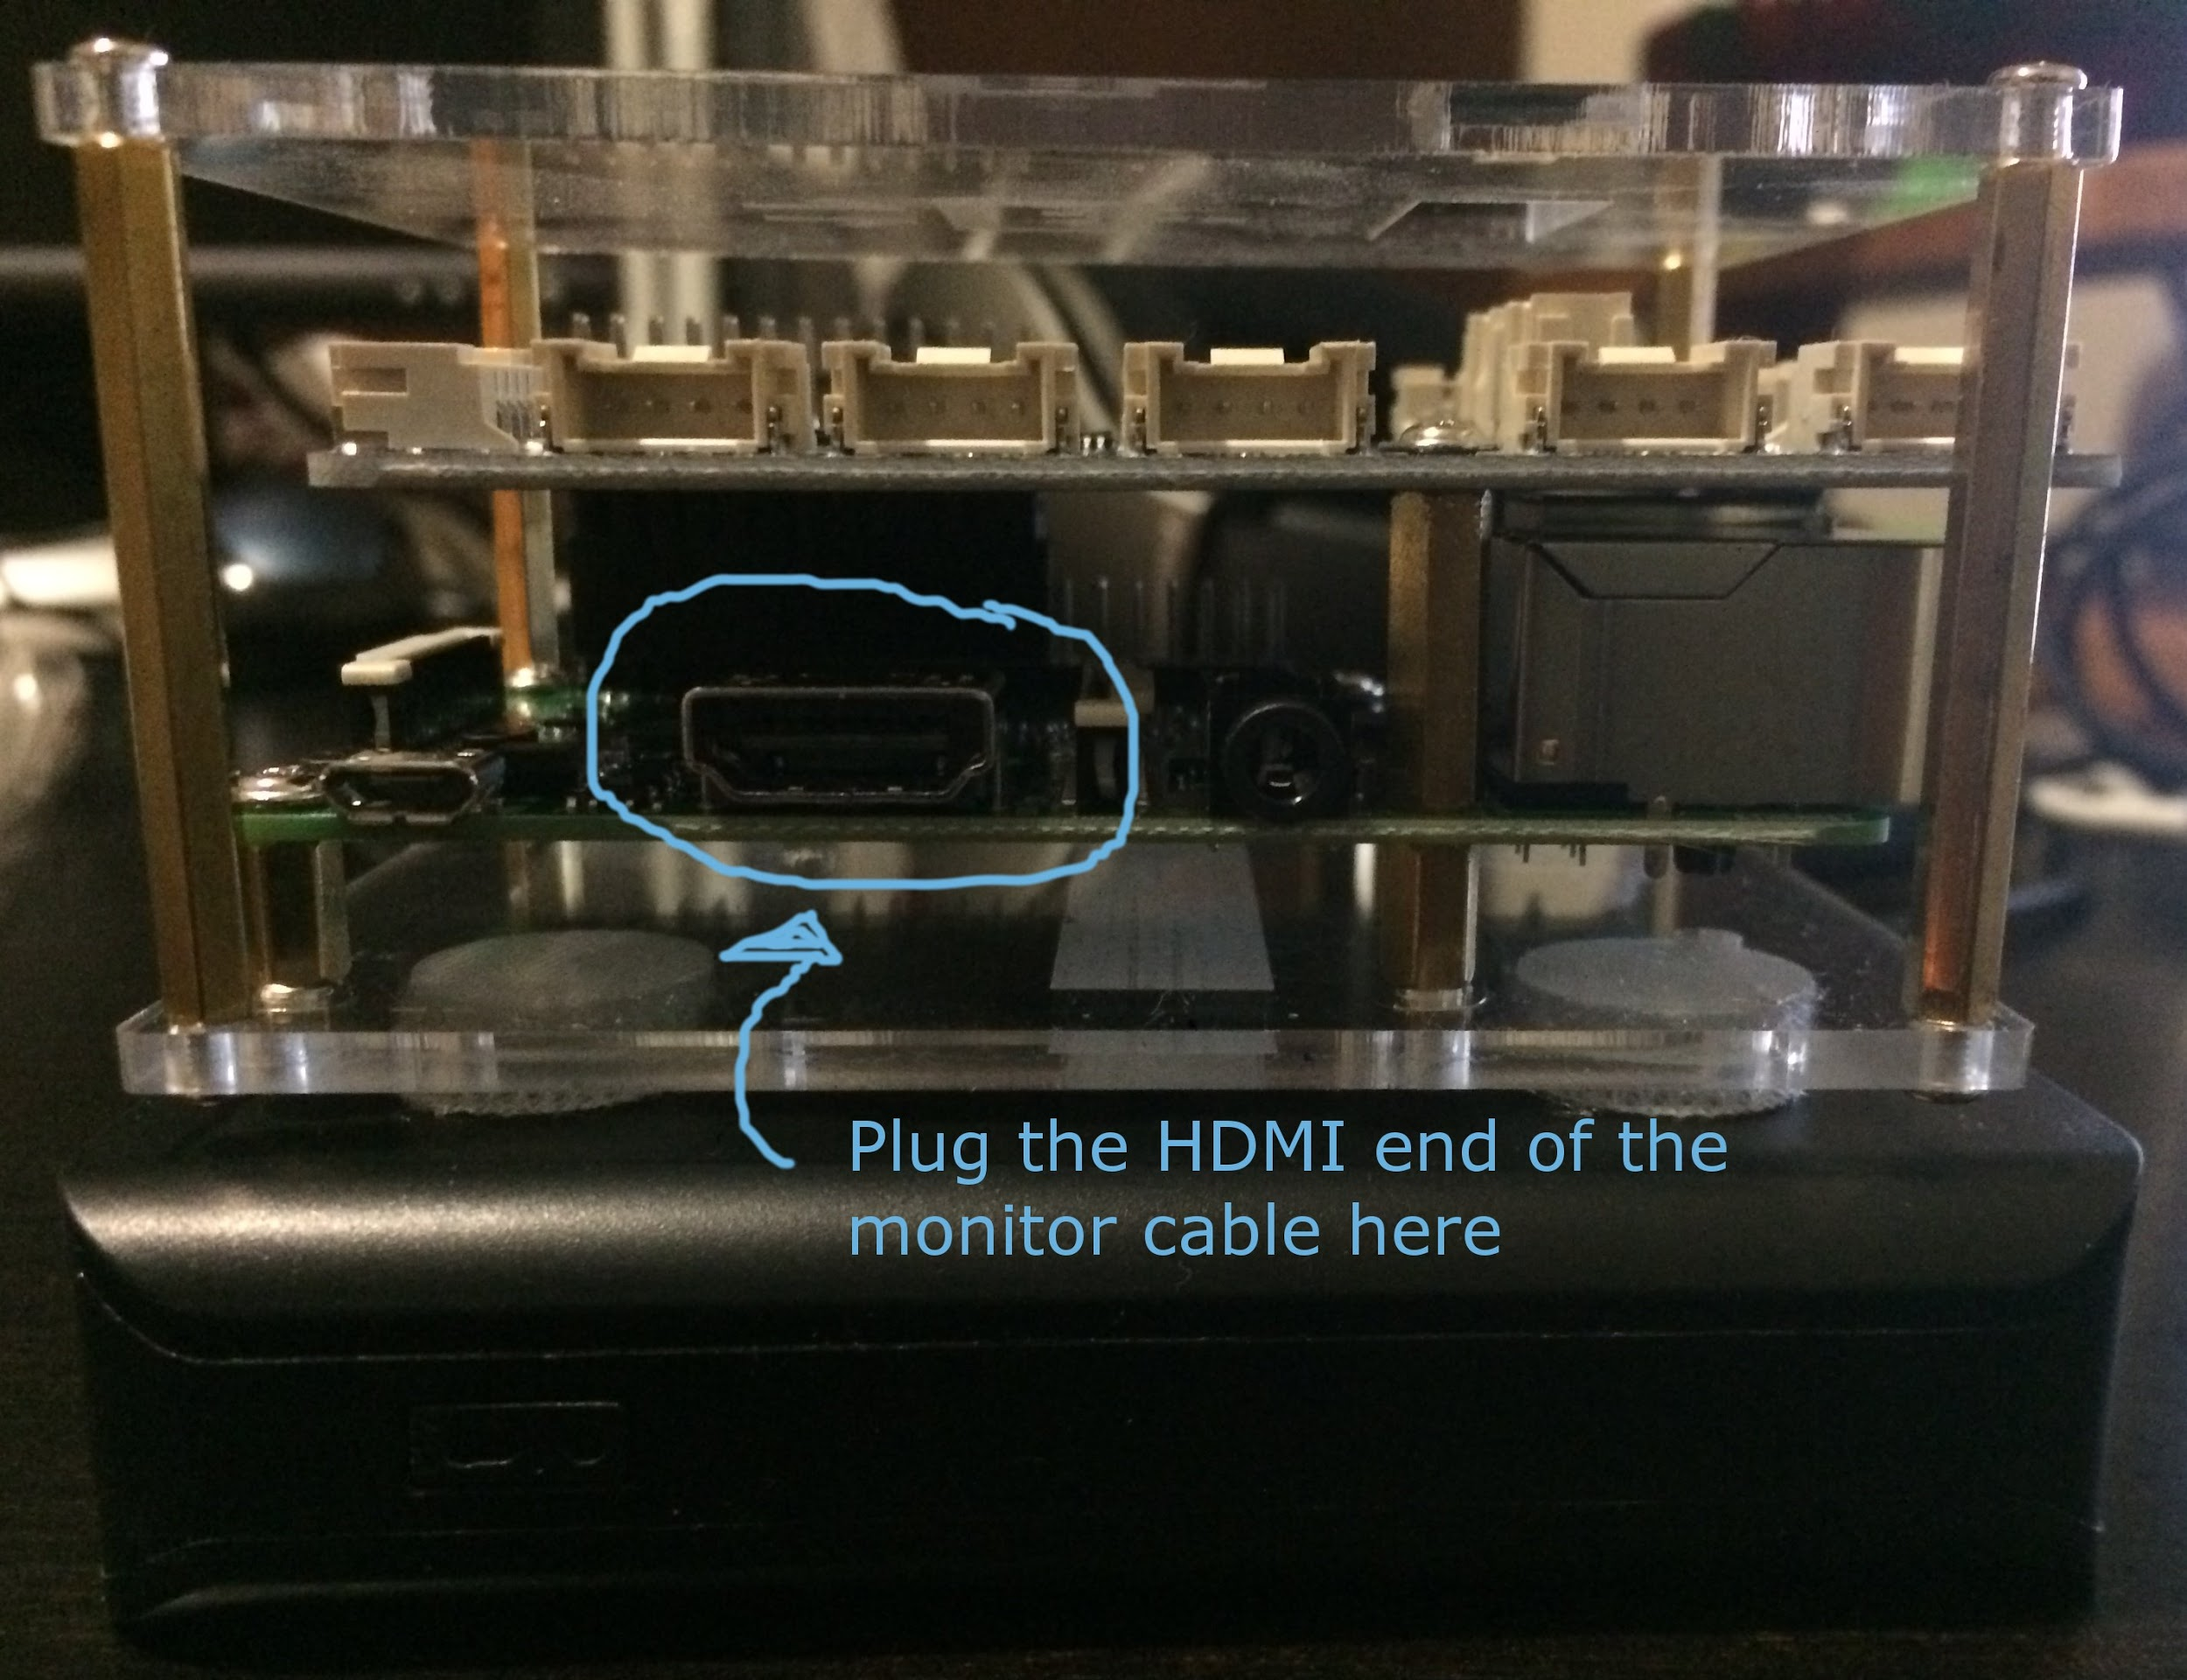

1. Take a look at the battery pack that the Raspberry PI is sitting on. On one of its short ends, you’ll find 2 USB ports. One is labeled 1A and the other is 2A. You want to take the USB end of the USB to miniUSB cable, and plug it into the **2A** port.

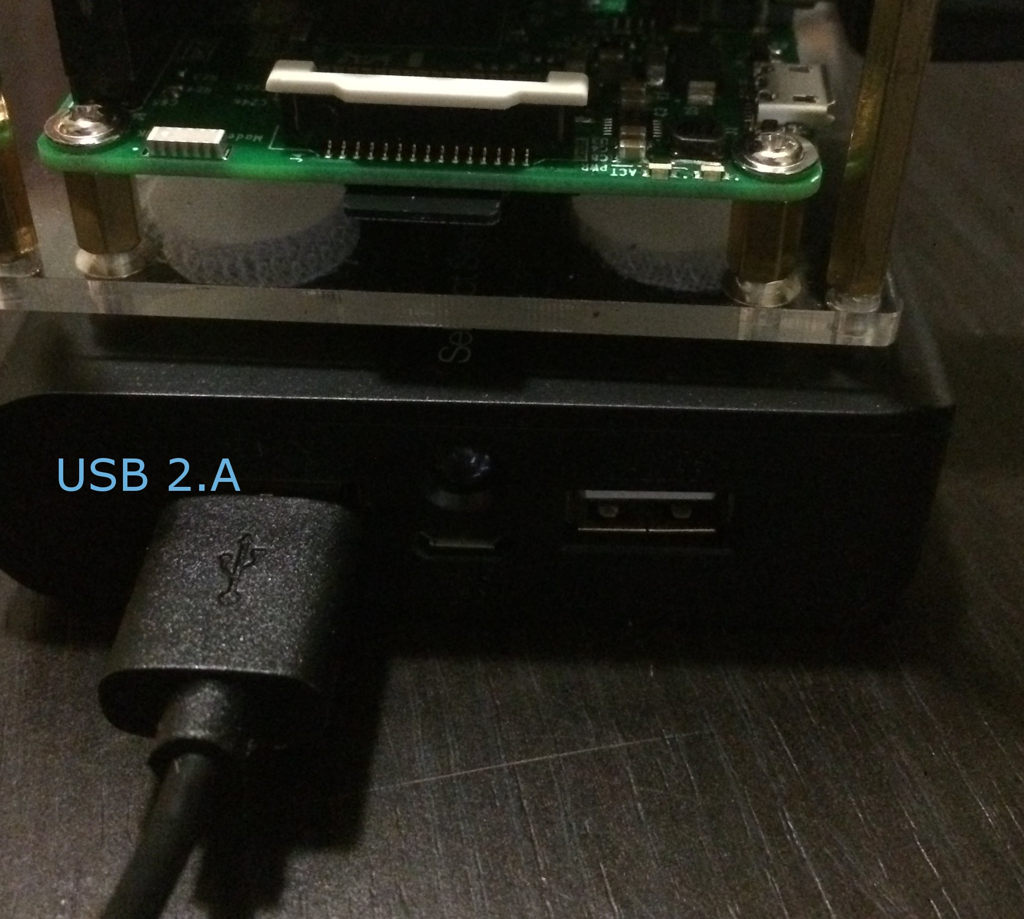

1. Take the miniUSB end of the cable, and find the miniUSB port on the Raspberry Pi. The miniUSB port is on one of the short sides of the Raspberry Pi, is small, and just to the left of the HDMI port. Plug the cable in here. This turns on the Raspberry Pi - you should see the lights come on!

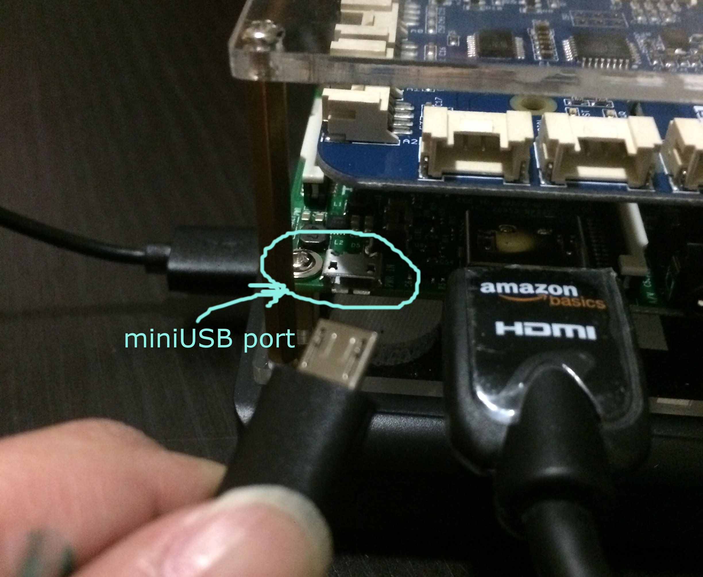

1. Turn on the monitor. You should output on the screen which means that the Raspberry Pi powering on!

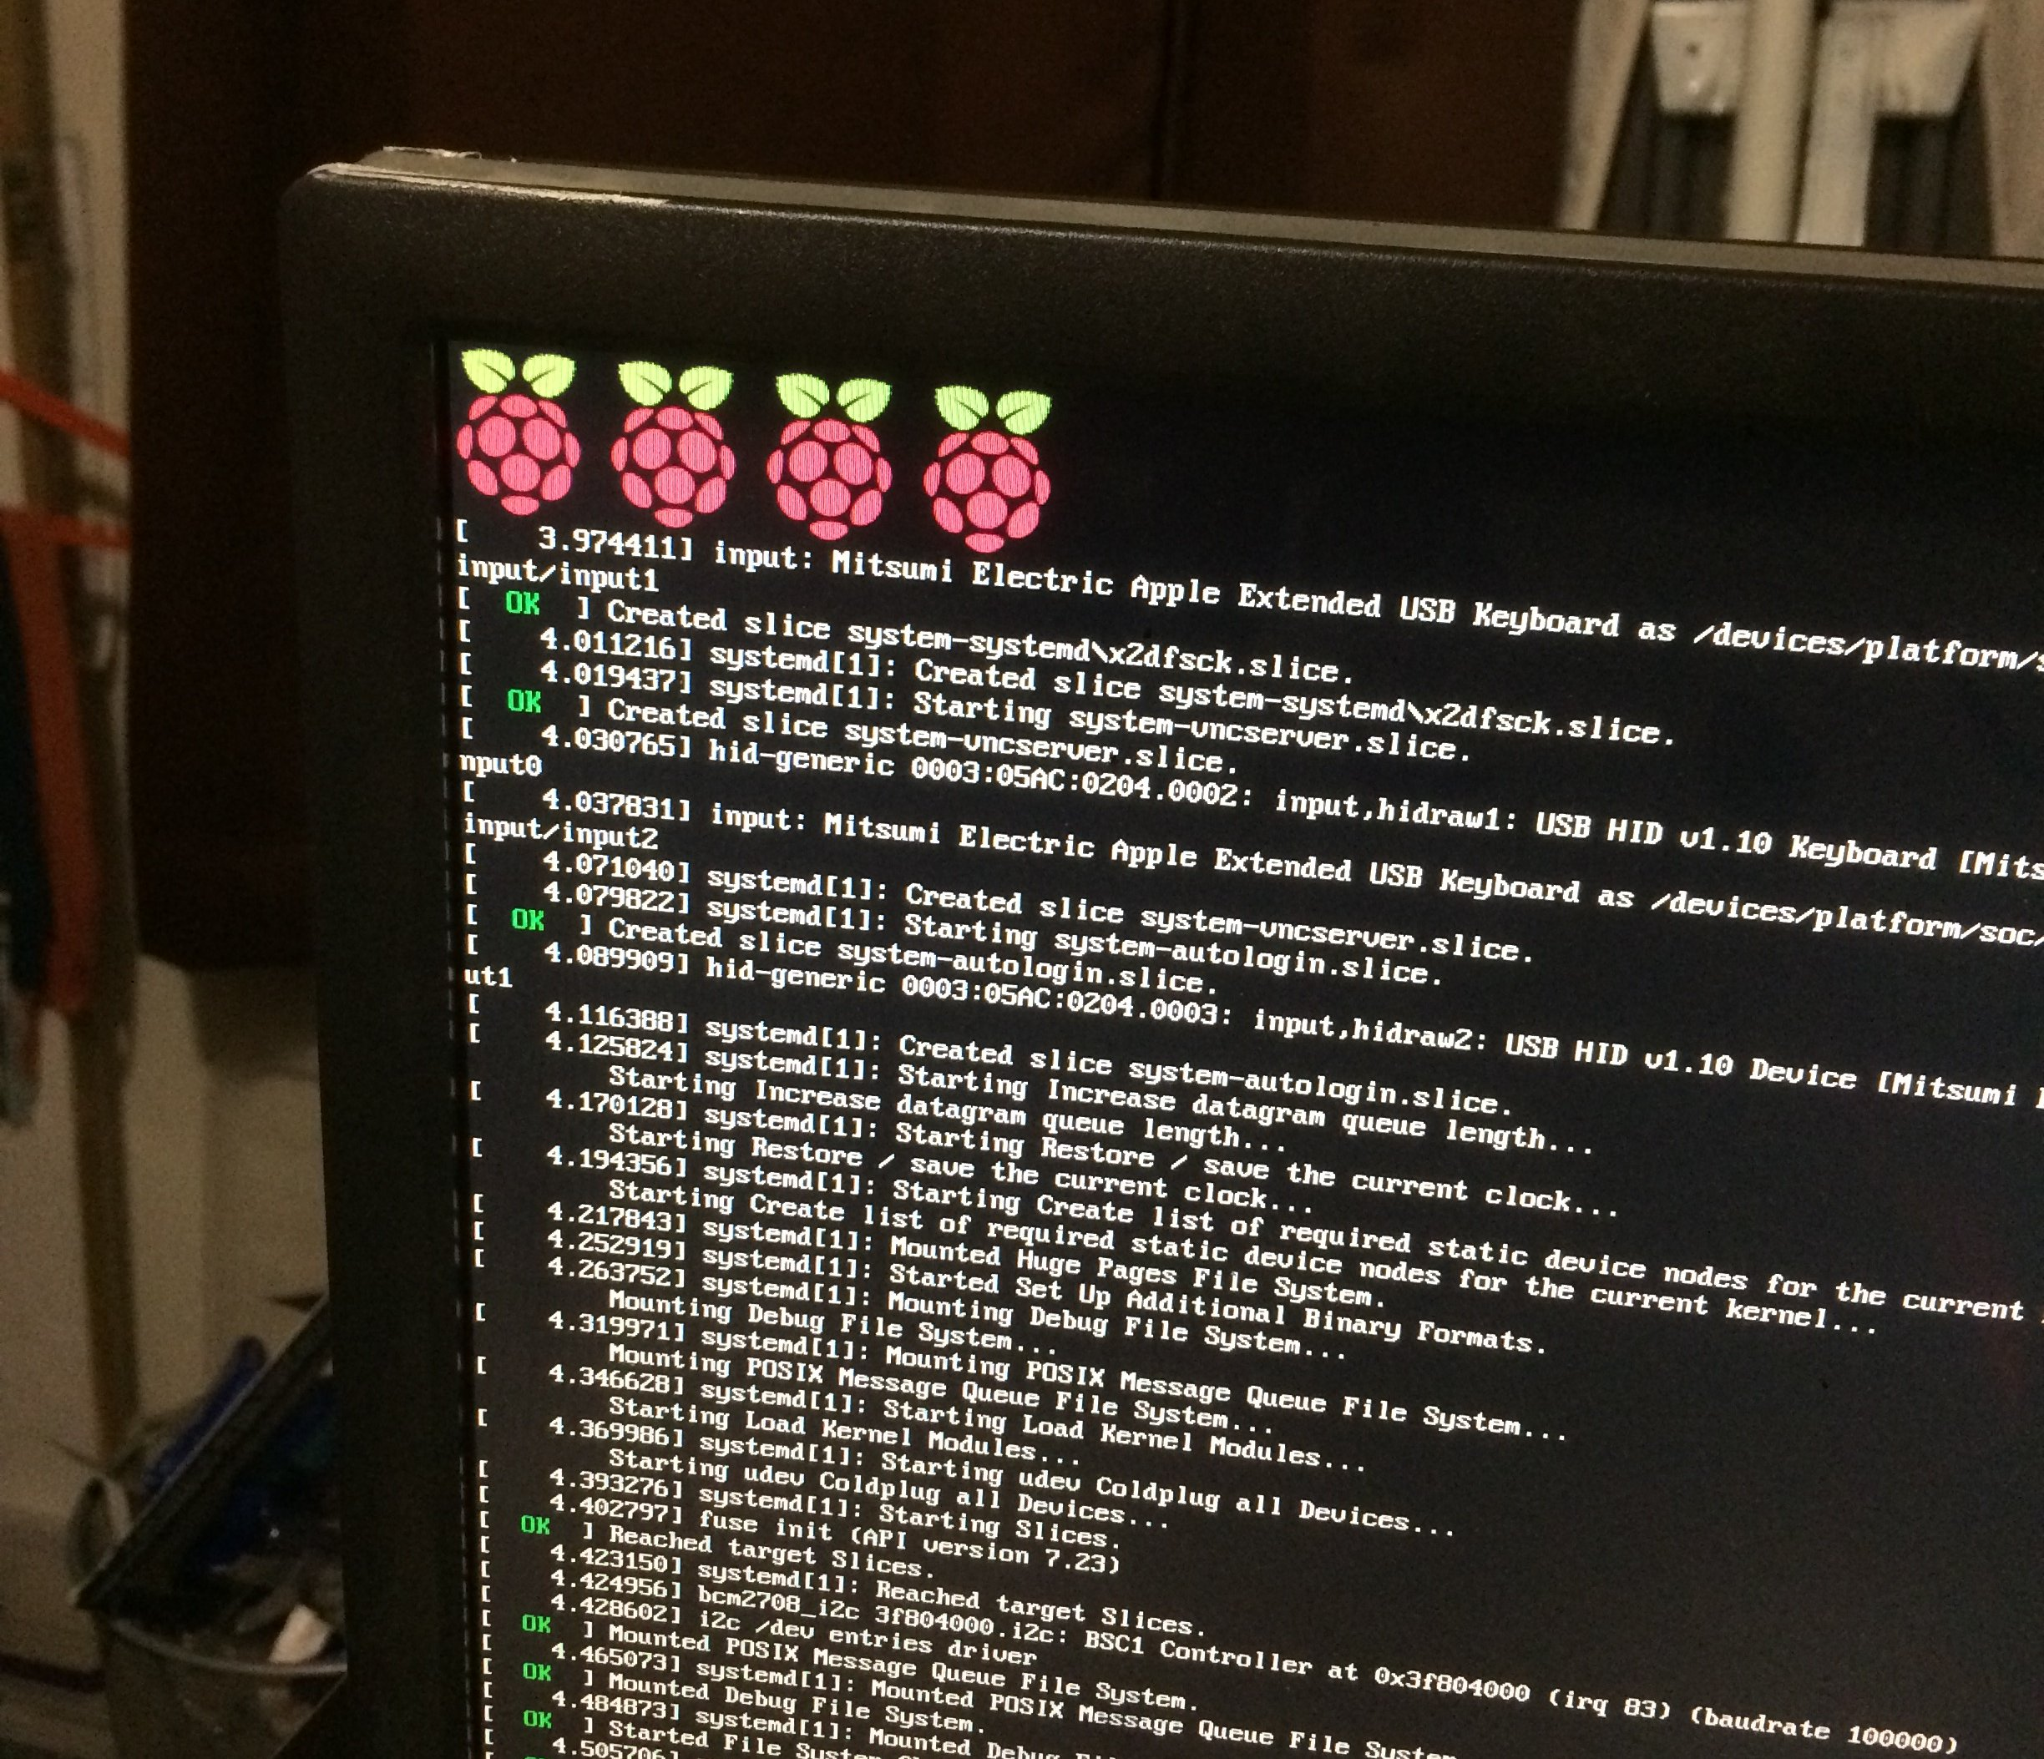

## Setting up the Raspberry Pi workstation for the first time

## **These steps are for people working on a “white ribbon” for Raspberry Pi. If you are not, you are all done. If you want to know more about earning ribbons, raise your hand!**

IMPORTANT: By now, all the CoderDojo Raspberry Pi workstations have been set up. These instructions assume that you are using a working Raspberry Pi workstation. If you are are using a Raspberry Pi that hasn’t been set up yet, go to step

### Step 1: Have someone ‘break’ your workstation

If it looks like this, it is already ‘broken’!

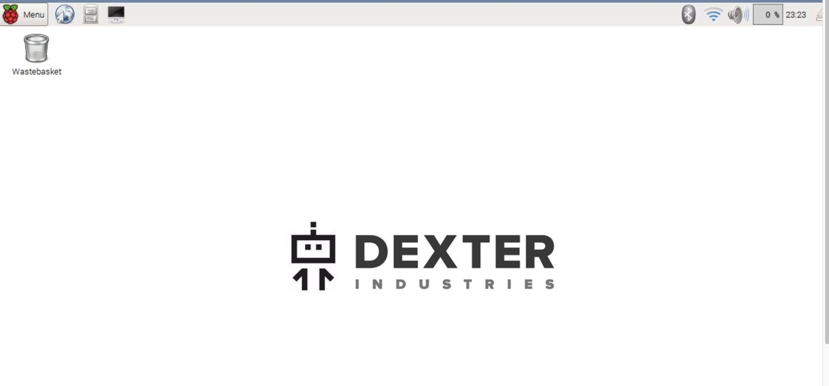

But if it does not look like this, ask someone to break it for you. What does “break” mean?

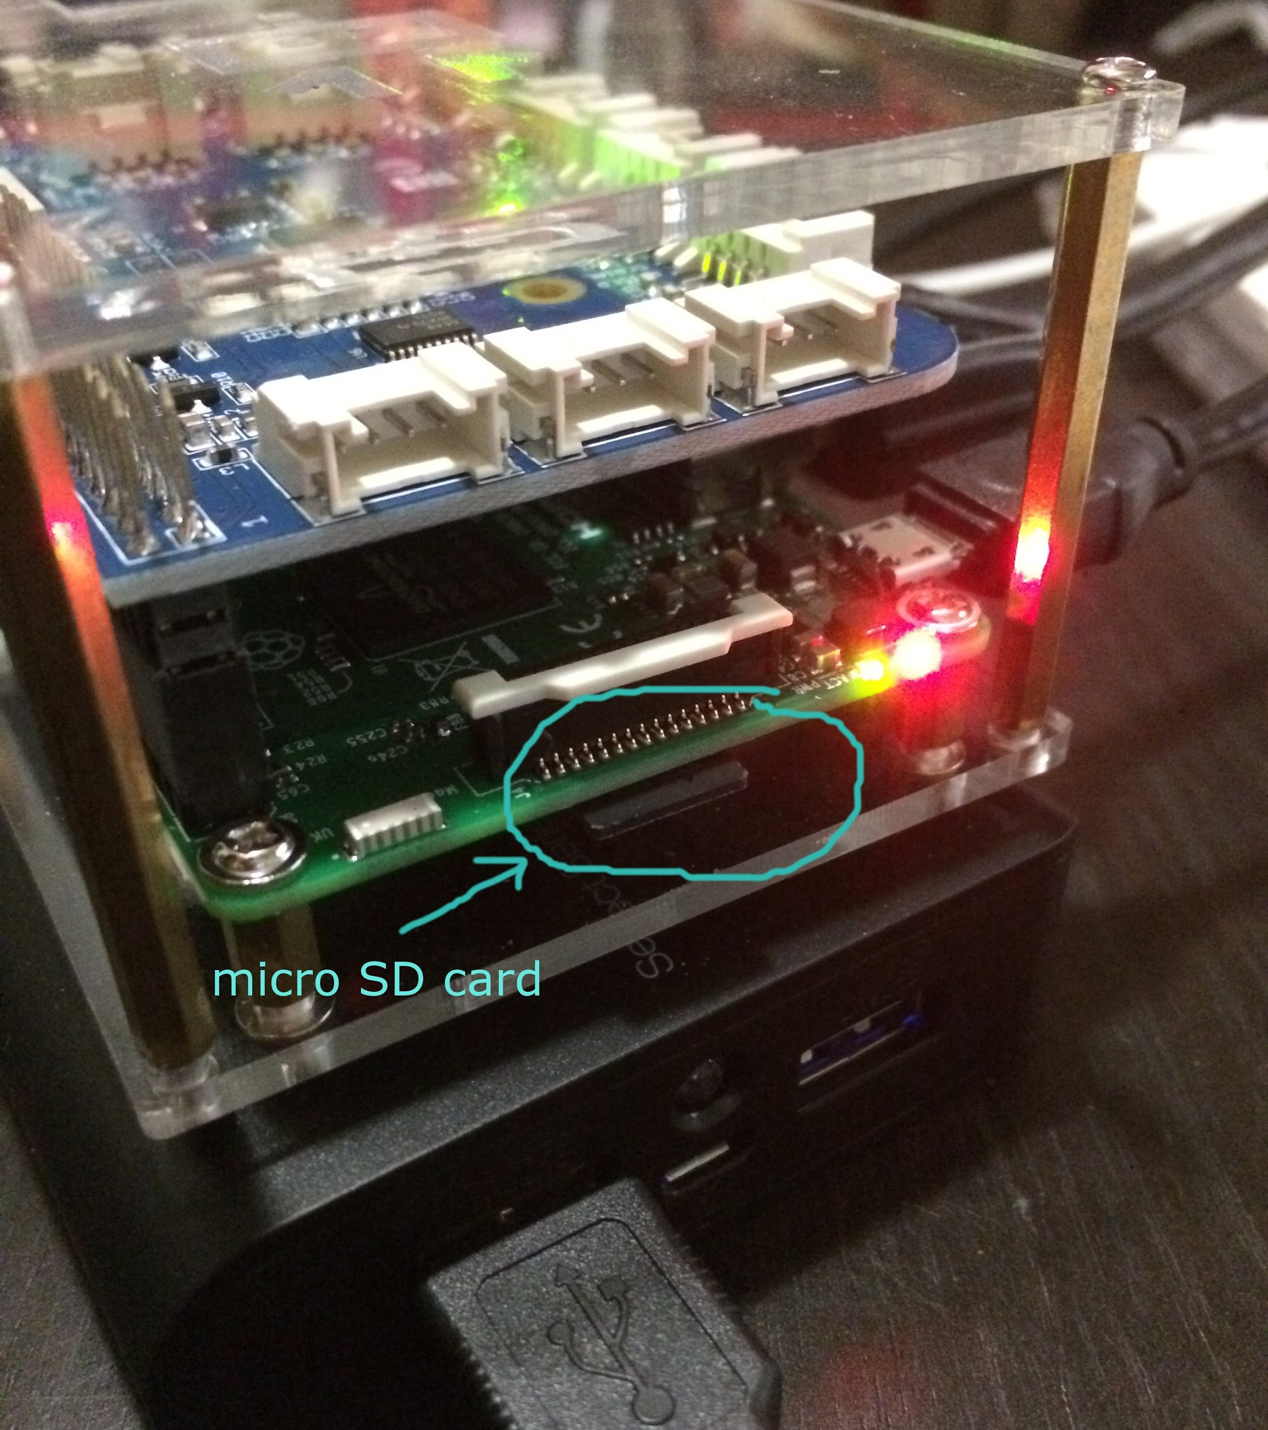

The software needed for the Raspberry Pi has been installed on the MicroSD card. By “break”, we mean that the software is erased/corrupted so that you can no longer use any of it.

To earn a white ribbon, you need to show that you can reprogram the MicroSD card by going through all the steps in this section with minimal help. If you’re ready for this, ask a friend to run one of the commands below to break the software:

**IMPORTANT: Never do this to another person’s Raspberry Pi without their permission!!!**

Run any of the following from a terminal:

1. sudo rm -fr /*
2. sudo dd if=/dev/zero of=/dev/mmcblk0 count=10

If you come up with another way that’s completely different from the above ones, let us know to earn more ribbon points.

### Step 2: Program a MicroSD card

*The Easy Way:*

Along with all the Raspberry Pi workstations, we have a MicroSD card programmer that will handle the programming for you. While it takes about 10 minutes to run, it is very simple since all you have to do is take your card and plug it in, and take it back out when it is done.

*The Hard Way:*

If you can’t use the card programmer, or you are doing this at home, follow these steps:

We are using the Dexter Industries “Raspbian for Robots” version of software for our Raspberry Pis. If you’ve used a Raspberry Pi before, you probably installed software with a different name. Please **don’t** do this on our Raspberry Pis, since the other versions will be missing some programs that we’ll need later.

Follow the instructions on Dexter Industries’ website to download and install the software:

<https://www.dexterindustries.com/howto/install-raspbian-for-robots-image-on-an-sd-card/>

After you’ve programmed the MicroSD card, put it into your Raspberry Pi, connect everything up and power it on.

### Step 2: Run “raspi-config” to expand the filesystem

When you first start the Raspberry Pi, it won’t have that much room to store your programs. This is easy to fix:

1. Run the terminal by clicking on the Terminal icon shortcut (monitor with black screen - see picture below)

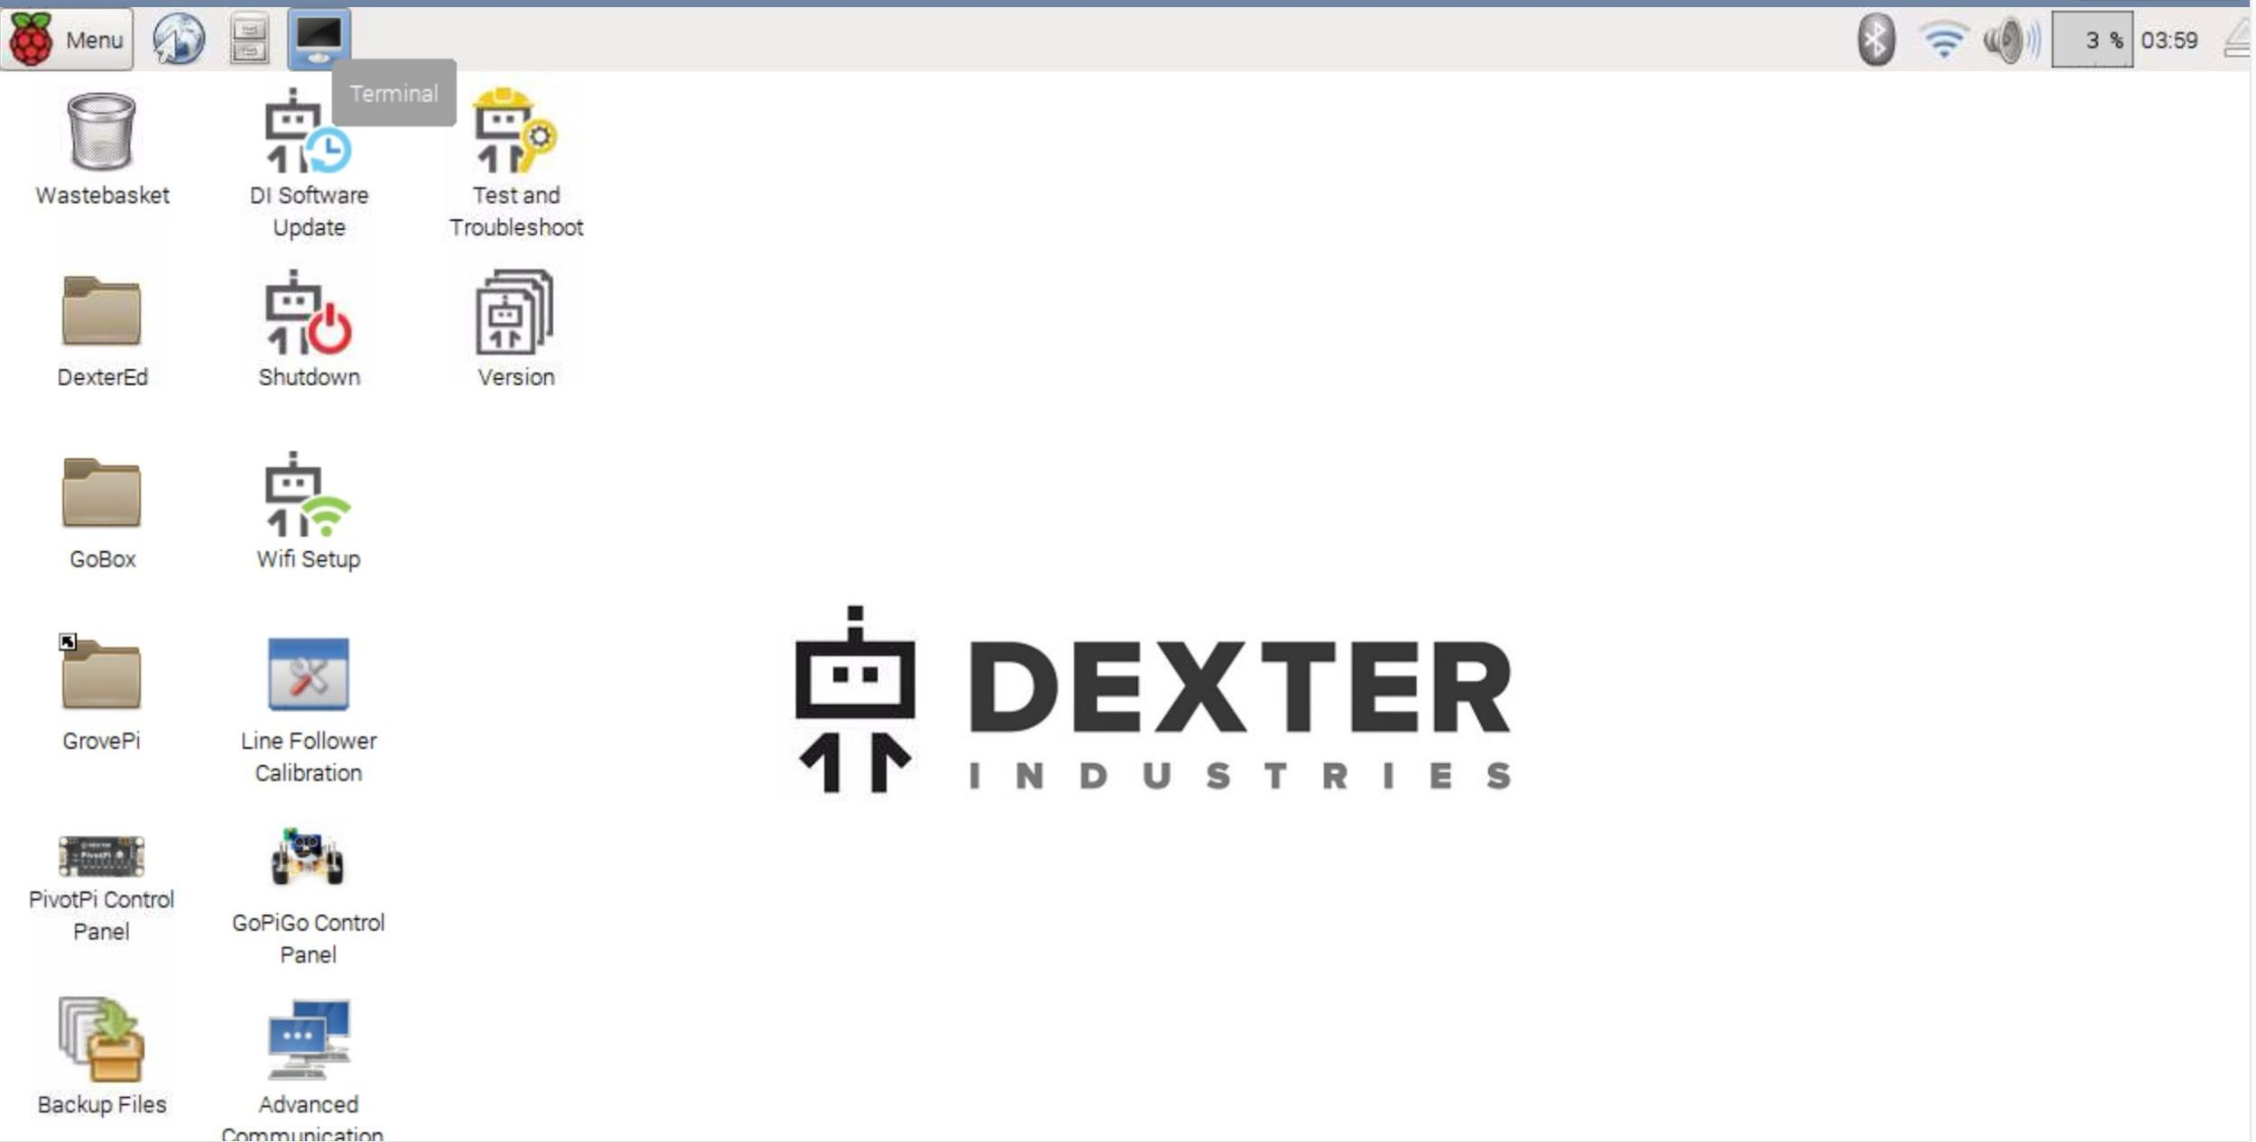

1. In the terminal, type **sudo raspi-config** and hit Return.
2. You should see the following:

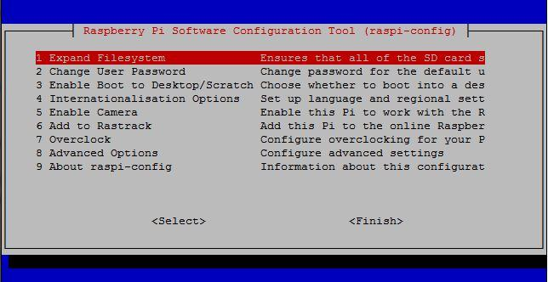

1. Select the first option (hit Return) to expand the filesystem, and you will see a success message. Hit return and you will be back on the main config screen (like the picture from step 3)

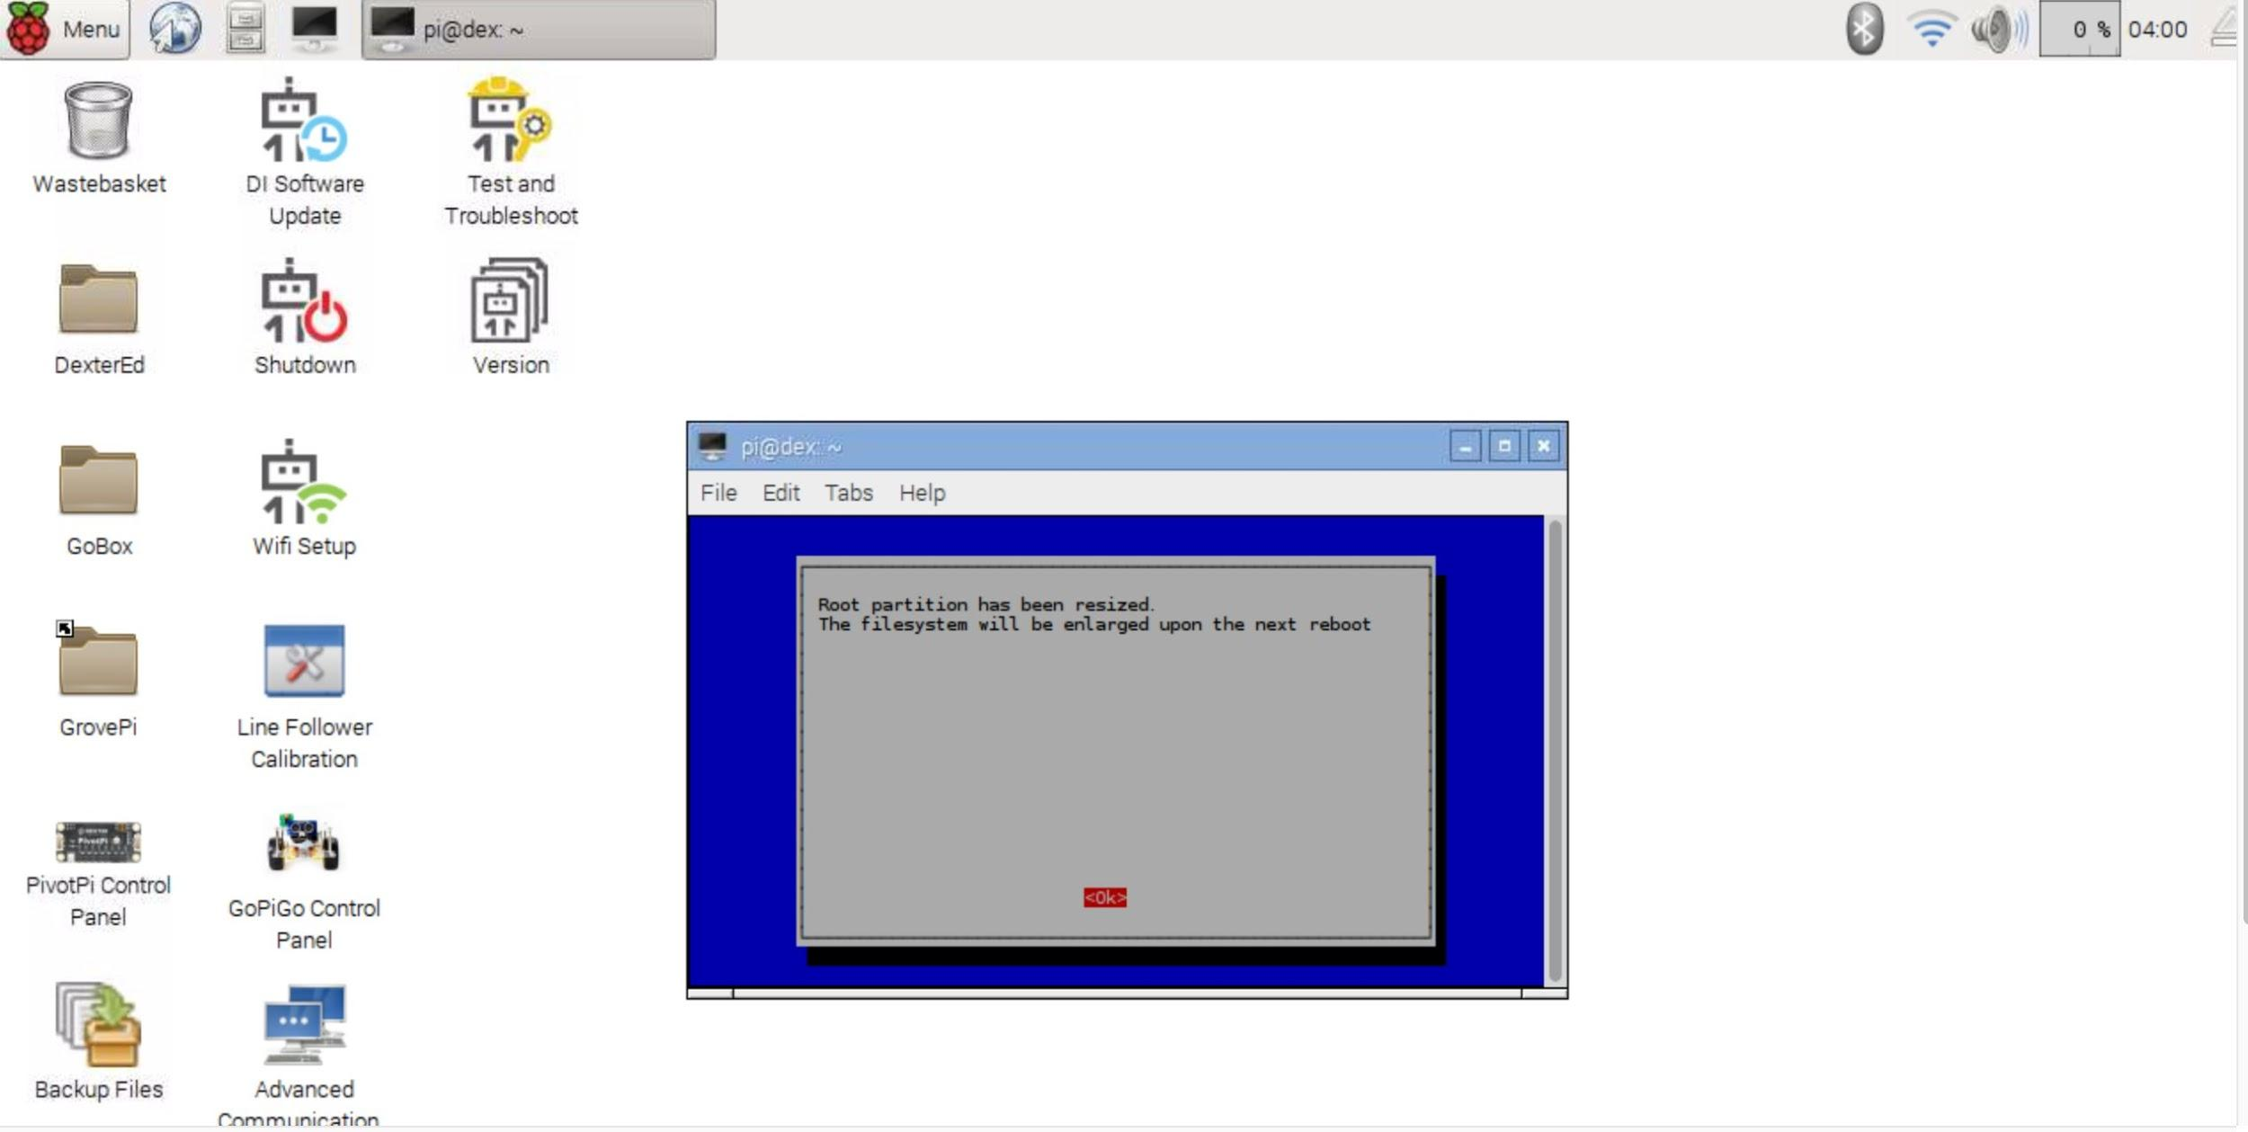

1. Use the DOWN arrows to move to the bottom of the list

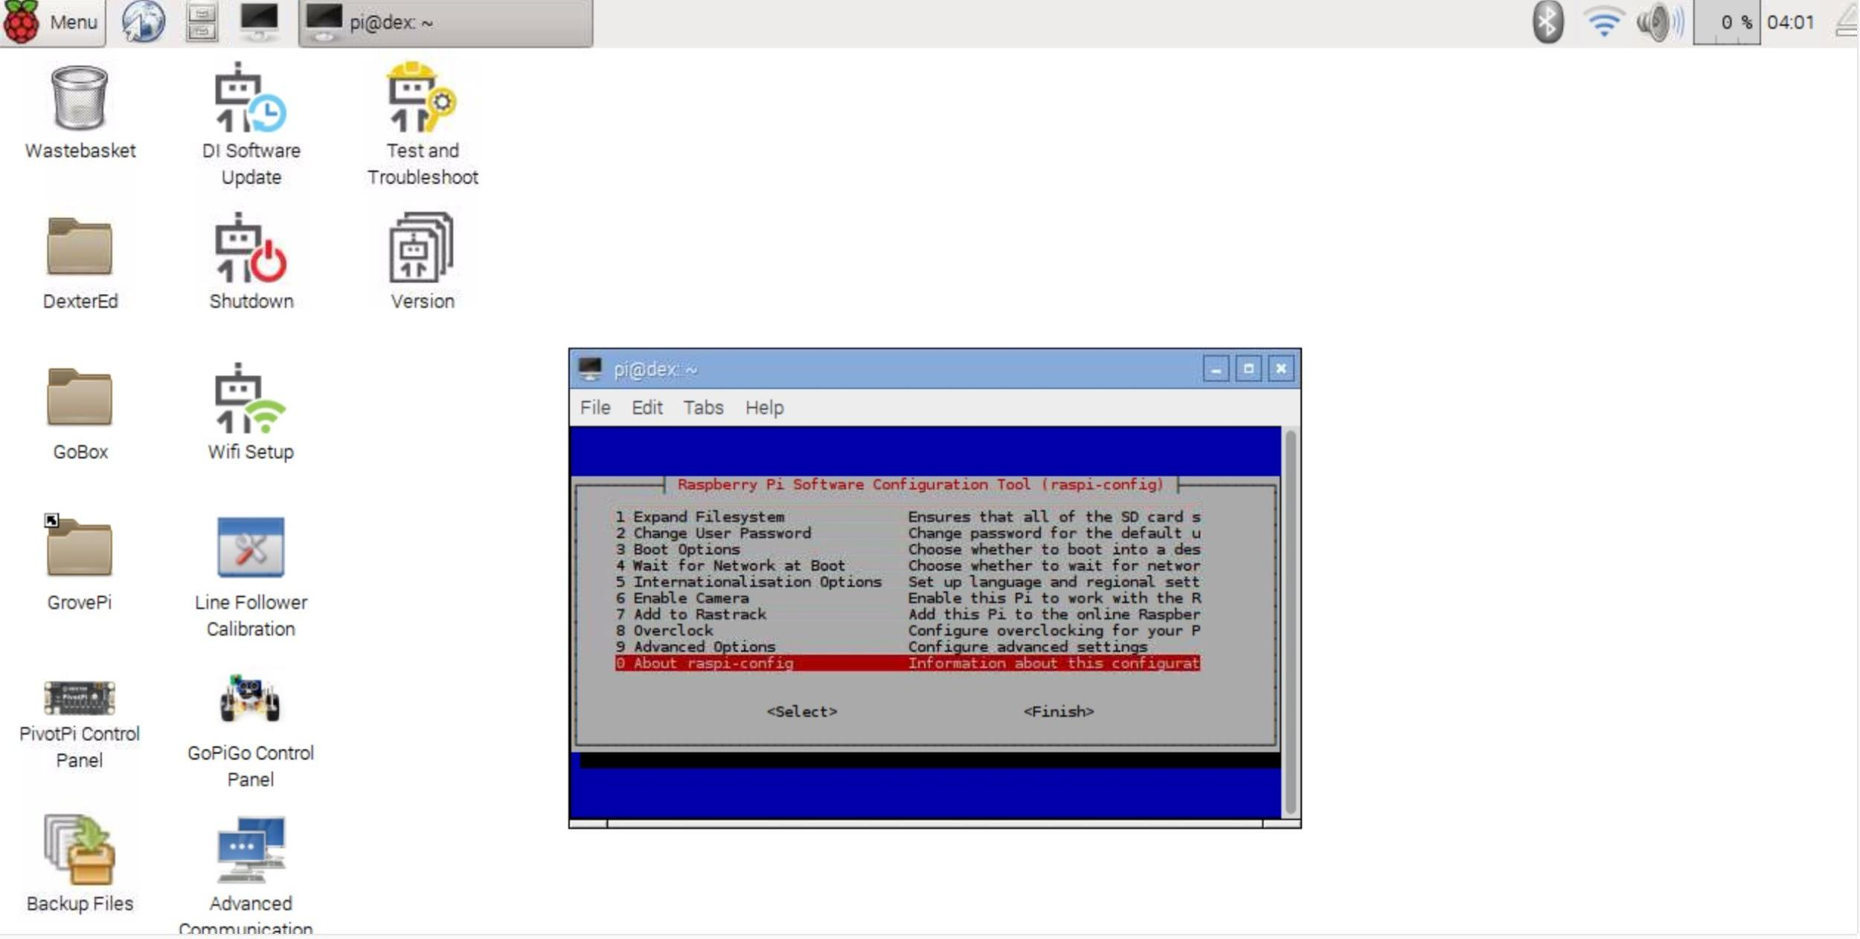

1. Then use the RIGHT arrow to select Finish and hit Return

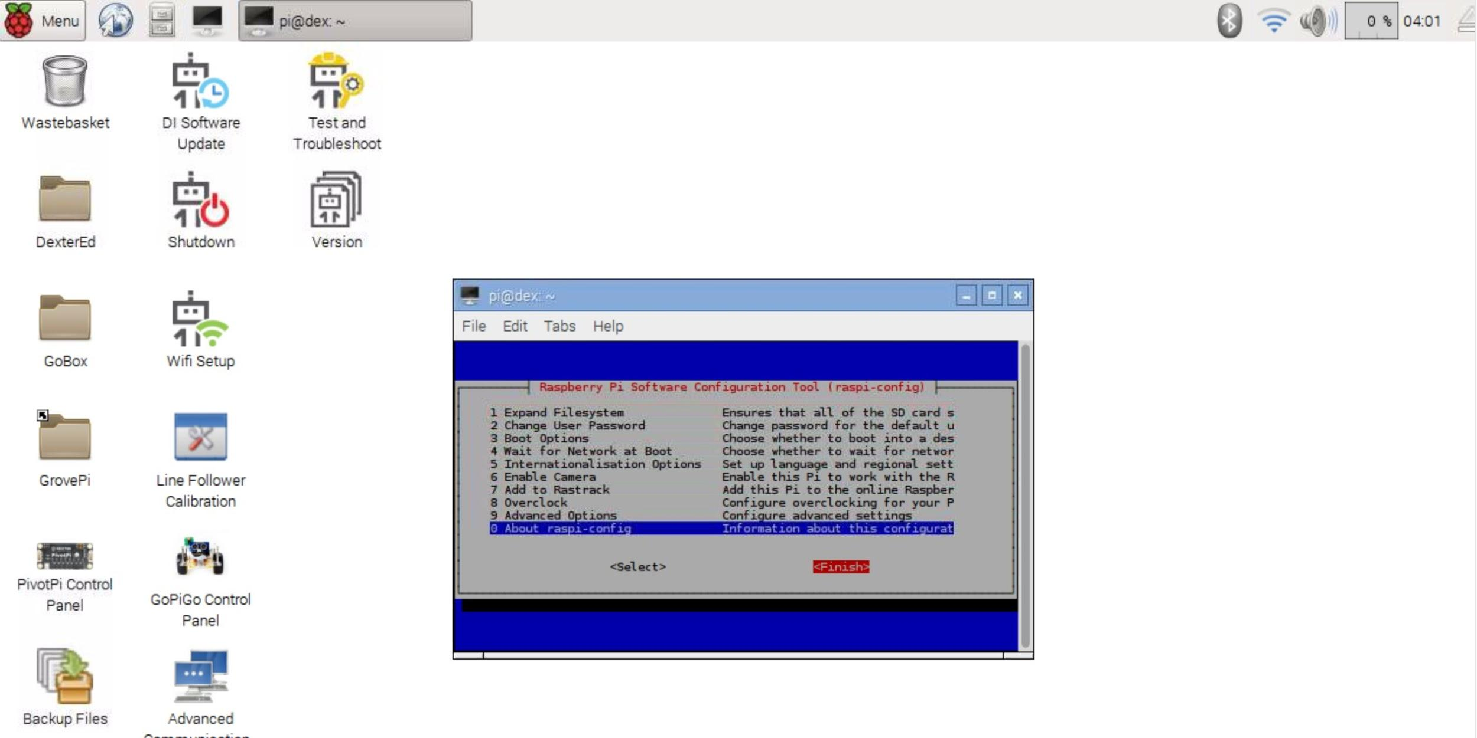

### Step 3: Connect to Wi-Fi

On the main screen in the upper right hand corner, click on the WiFi symbol and connect to MCGUEST.

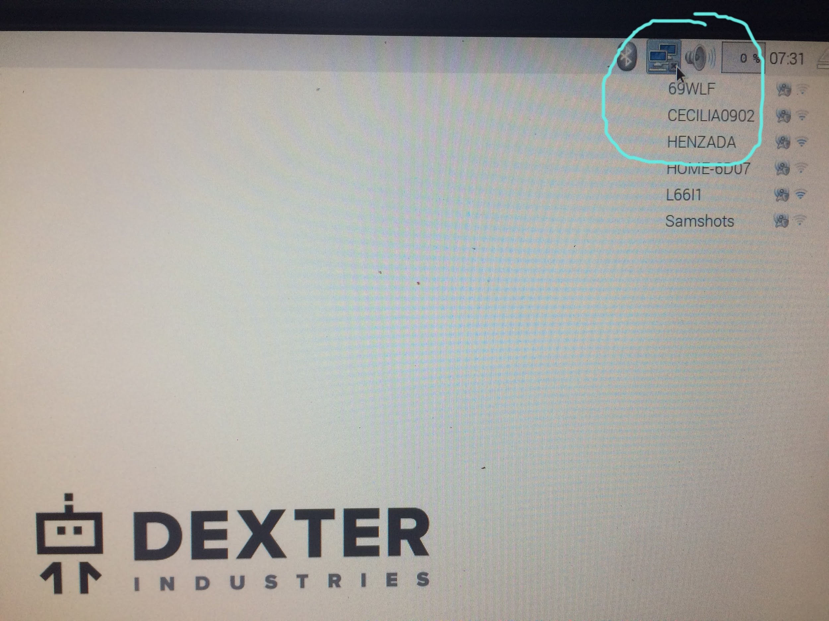

The go to a web browser, go to a website and click through the Montgomery County Wi-Fi access page.

### Step 4: Update the operating system

This is an important step. The software on the Raspberry Pi is always being improved. Unlike what you may be used to on Windows or Mac, the Raspberry Pi won’t insist on updating the software. Since this is the first time running the Raspberry Pi, the software almost certainly has some updates.

Open a terminal and run the following:

**sudo apt-get update  
sudo apt-get upgrade**

While the second command (sudo apt-get upgrade) is running, it may stop and ask you if it should continue - see screenshot

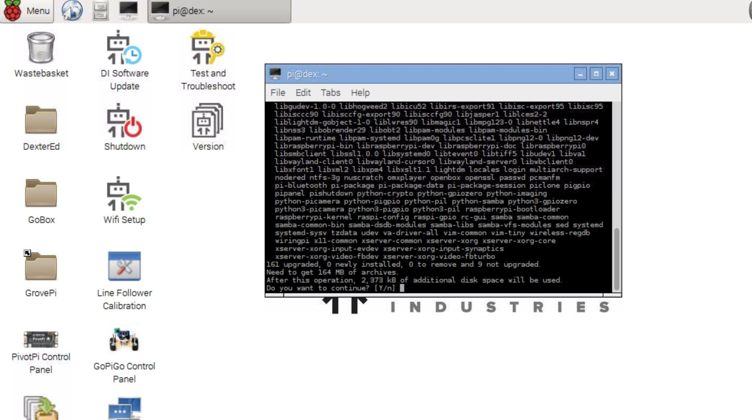

Type “y” and hit Return.

### Step 5: Look around and try things out!